Exercise: SWOT analyses
A SWOT analysis can help you defining the strategy of your organization.

Take a good look at the organization you work in.
Define in sub groups of max four in 30 minutes one or more examples of the four blocks in the attached sheet.
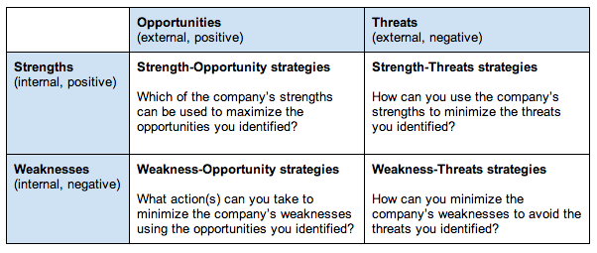
Each sub group present their outcomes on the flip chart.
Discuss in plenary the quality and usefulness of the SWOT’s.

